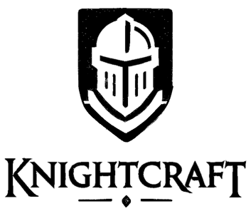
Open-Source Knights is a framework of rules for playing D&D with a much greater emphasis on streamlined gameplay and creative flexibility.

Where Open-Source Knights is Different from D&D:
- The dice: one d20, ten d6, one set of percentile dice (aka a "d100"). There is no d4, d8, or d12.
- The core mechanic remains: roll a d20, add a modifier, compare to a target DC number set by the GM.
- Rather than using predefined abilities, you design custom ability cards to fit your character.
- Instead of spell slots and other resources, all abilities are managed with a "Cooldown Queue".
- Advantage and Disadvantage can stack up to twice ("roll three d20 and take the highest/lowest").
- Each character has ten "Recovery Points" they spend to heal between Long Rests.
- If you run out of Recovery Points, you can no longer heal. A Long Rest restores them. There are no Short Rests.
- Initiative uses a "zipper" system: play passes back and forth between the player and enemy teams.
- Armor Class is a single number for each team. The player team AC is based on the team's level.
- On your turn in combat, you can take up to 3 Actions.
- Rolling a Nat 1 on an Ability means it does miss completely. Rolling a Nat 20 grants precalculated bonus damage.
- Rolling under an opposing team's AC results in a weaker result, but not a complete miss.
- Skill changes: "Perception" is removed; "Persuasion" works differently; "Engineering" and "Language" are new.
- There are no Bonus Actions, Reactions, or Attacks of Opportunity.

Cards: The Deck and The Loadout
- All of your character's abilities and equipment are represented as a Deck of index cards you create.
- Your Deck can contain an unlimited number of cards. You design new Ability cards as you level up.
- Your "Loadout" is a subset of 10 cards that represent abilities/equipment you can use on your turn in combat.
- Outside of combat, you can swap cards between your Loadout and your Deck any time you want.
- In combat, you must take the "Reconfigure" action to swap cards in/out (see below).

Your Character At A Glance:

 Character Sheet: Your character's main stats
Deck: Cards representing all of your character's abilities and gear
 Loadout: The 10 cards available to you on a given turn in combat
Cooldown Queue: Abilities you've used recently, which aren't usable again yet

On Your Turn In Combat
- You can take up to 3 Actions.
- You can use the same type of Action no more than twice on a single turn.
- You can only add ONE card to your Cooldown Queue per turn, unless another card has the "Combo" trait.
- You can also "Hold" any type of action and define a "Trigger" that activates it between your turns.

Types of Actions
- Use Ability – Activate an Ability card, and move it into the Cooldown Queue if necessary
- Use Equipment – Activate an Equipment card, and move it into the Cooldown Queue if necessary
- Use Consumable – Use a one-time-use card (such as a potion).
- First Aid – Make a Medicine check to restore that much HP to yourself or an adjacent ally.
- Movement – Move a number of squares equal to your Movement value.
- Reconfigure – Declaration to swap cards between your Loadout and Deck (AFTER your turn ends).
- Wildcard – Do anything that makes sense for your character in the current situation (see below).

Wildcard Guidance:
- You cannot use your Wildcard to duplicate any other Action type.
- You cannot use your Wildcard to ONLY cause more damage (it is not an "extra attack").
- Wildcards can involve whatever weapons you are currently wielding.
- Wildcards generally involve little-to-no magic or supernatural abilities.
- Repetitive or abusive Wildcard tactics can incur disadvantage; creativity and drama may grant advantage.

The Cooldown Queue
- The Cooldown Queue consists of two "Cooldown Slots".
- If an Ability or Equipment card says it "Requires Cooldown", you place the card into the first slot of your Cooldown Queue after using it. After doing so, the card that was previously in the first slot moves into the second slot. The card previously in the second slot is moved back into your Loadout, and can be used again.
- In other words, when an ability is first moved into the Queue, you must add 2 more cards to the Queue in order to use it again.
- You can only insert ONE card into your Cooldown Queue per turn (unless you use a Combo Card).
- Cards with the "Combo" feature allow you to play them into the Queue on the same turn as another card that requires cooldown. They can be played either before or after that card, and are placed on top of (or below) that card in the same Cooldown Slot.

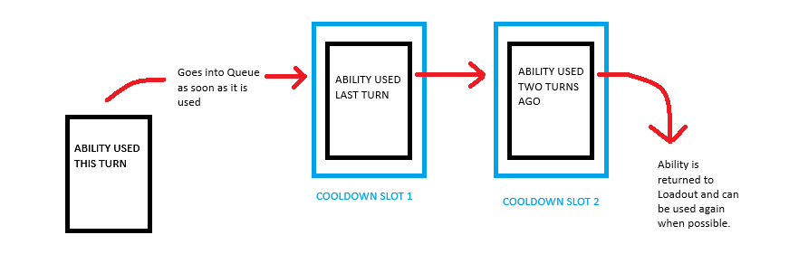

Character Creation:
- Characters in OSK consist of one Species, and two Classes.
- At Level 1, create your Species card, choose your two Classes, fill in your starting stats, and design 5 Ability cards.
- A Species card has 1-3 traits. It is always available to you, and it DOES NOT count as part of your Loadout.
- Your classes are not primarily a fixed progression with predefined options; rather, classes merely function as guidelines for what kinds of Ability cards you design for your character.
- The GM determines when the party levels up. You gain levels in both classes simultaneously.
- Character statistics are highly standardized and streamlined – most of your character's distinctiveness will come from your Designed Ability cards.
- Attribute / Skill Points each allow you to fill in one of the corresponding bubbles on your character sheet.
- Character Progression Chart:
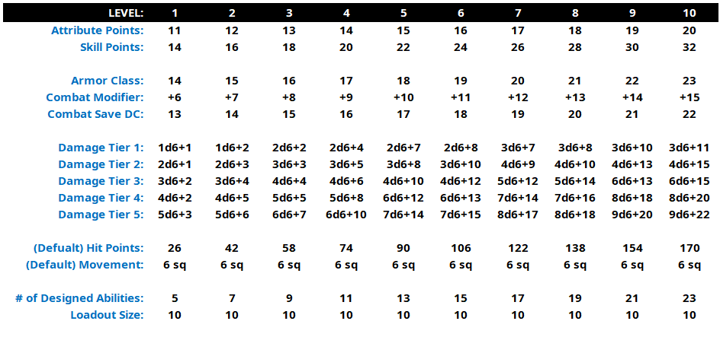

Ability Design Basics
- Every Ability must fit comfortably on one 3x5 card and resolve quickly during play.
- Start with a Source Ability from one of your Classes that is approximately appropriate to your level.
- Source Abilities can come either from the OSK Example Card Compendium, or from another TTRPG entirely.
- Preserve the Source Ability’s fantasy, function, or both. You do not need to preserve its exact mechanics.
- Clearly define only the mechanics it needs: range, targets, rolls, damage, duration, limitations, etc.
- Power comes from tradeoffs: increasing damage, range, targets, reliability, control, or utility should usually mean giving something up elsewhere.
- Avoid Abilities that trivialize broad categories of challenges, rewrite core rules, or require excessive tracking.
- Ability design is a collaborative conversation. Revision after play is expected.
- The GM has the final say on whether or not an ability is balanced in its current form.
- Create complex characters by cleverly combining simple cards – not by writing complex cards!

